**UCS 2312 Data Structures Lab**

**Exercise 11: Implementation of Hash Table using Closed and Open addressing methods**

**[CO2, K3]**

The HashTableADT contains hash table and its size. Hash function to be used for the insertion of elements is ***x mod tableSize***. Use Separate chaining method to resolve the collision.

* void init(HashTableADT *H) – To initialize the size of Hash Table
* void insertElementL (HashTableADT *H, int x)– To insert the input key into the hash table
* int searchElement(HashTableADT *H, int key) – Searching an element in the hash table, if found return 1, otherwise return -1
* void displayHT(HashTableADT *H) – Display the elements in the hash table

**Note:**

1. Implement HashTableADT with the specified operations in HashTableADTImpl.h
2. Write a menu driven application to utilize the HashTableADT.

1. Demonstrate ADT with the following test case

insert 23, 45, 69, 87, 48, 67, 54, 66, 53

Contents of Hash Table

(Separate Chaining)

1. :
2. :
3. : 3 : 23 → 53
4. : 54
5. : 45
6. : 66
7. : 87 → 67
8. : 48
9. : 69

2. Create another hash table ADT with following functions for open addressing methods, namely, Quadratic probing and Double Hashing.

* void insertElementL (HashTableADT *H, int x)– To insert the input key into the hash table
* void displayHT(HashTableADT *H) – Display the elements in the hash table

Note: For Double hashing, the second hash function is 7-(x%7)

Demonstrate the ADT with the following testcase

(i) Contents of Hash Table

(Quadratic Probing)

1. →
2. →67
3. →53
4. →23
5. →54
6. →45
7. →66
8. →87
9. →48
10. →69

(ii) Contents of Hash Table

(Double Hashing)

1. →67
2. →
3. →53
4. →23
5. →54
6. →45
7. →66
8. →87
9. →48
10. →69

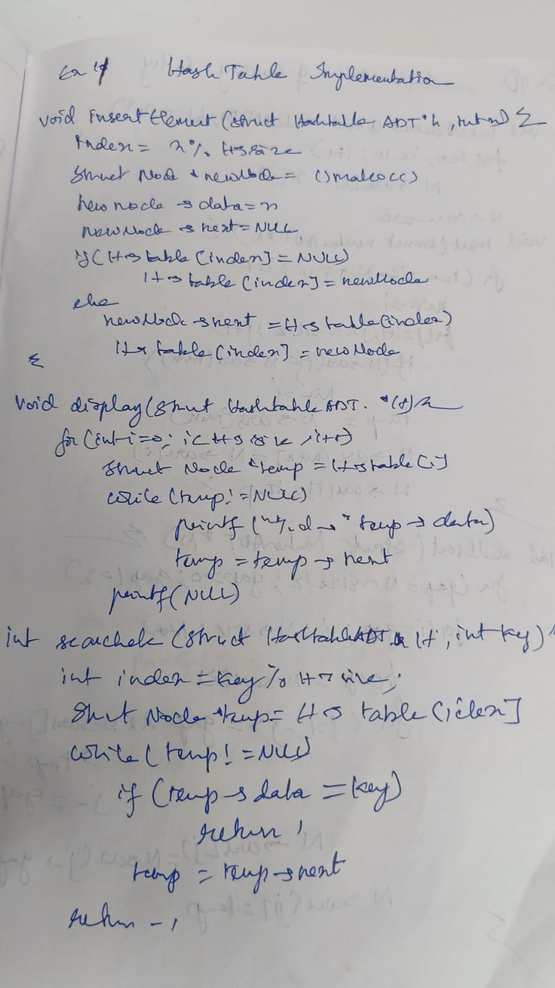

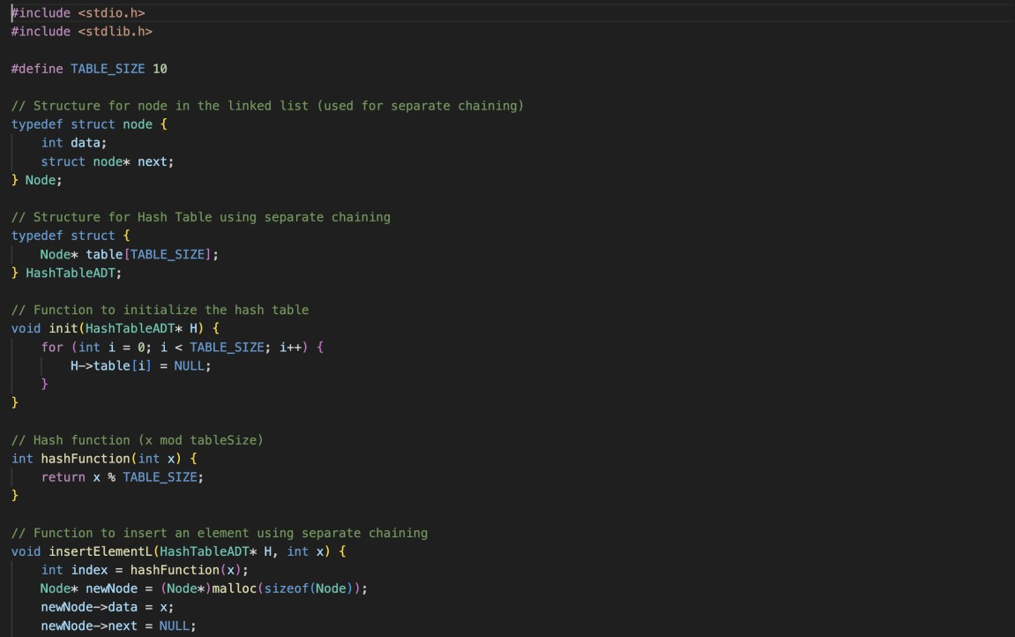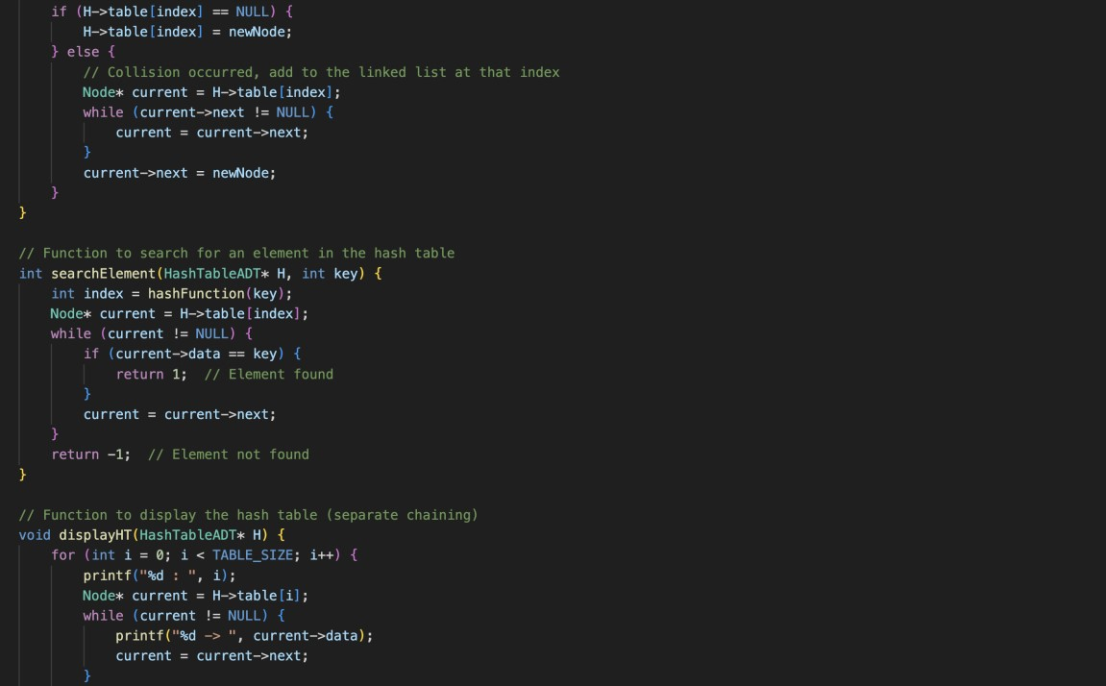

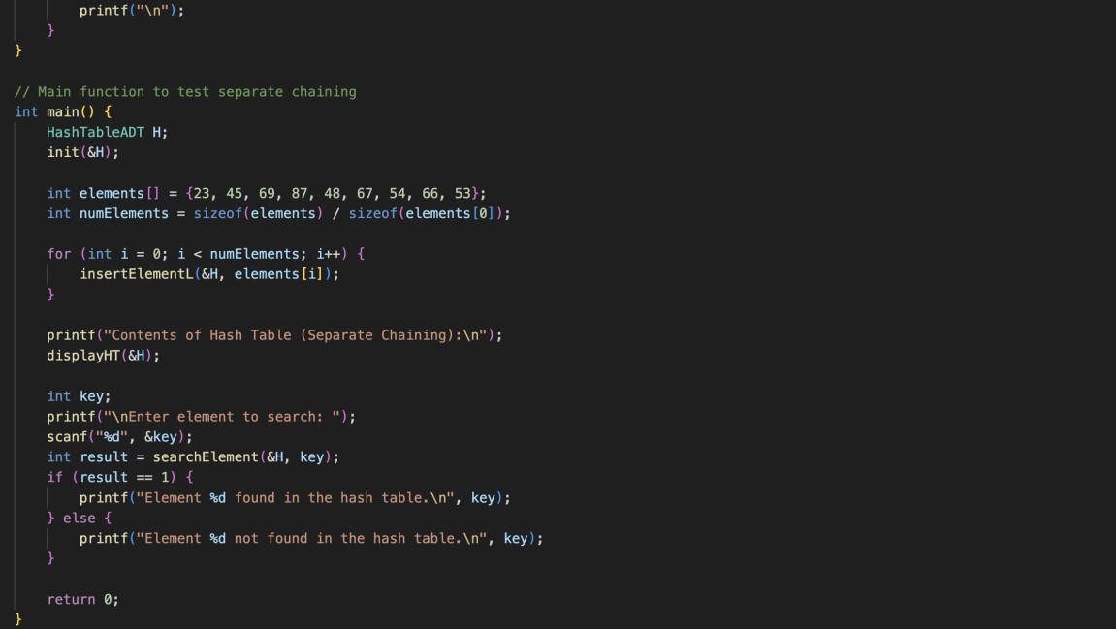

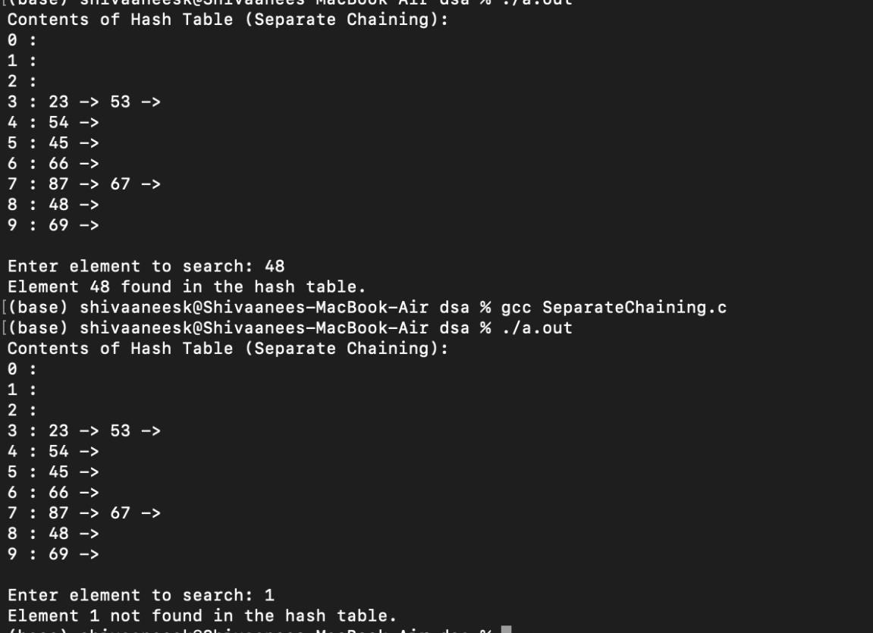

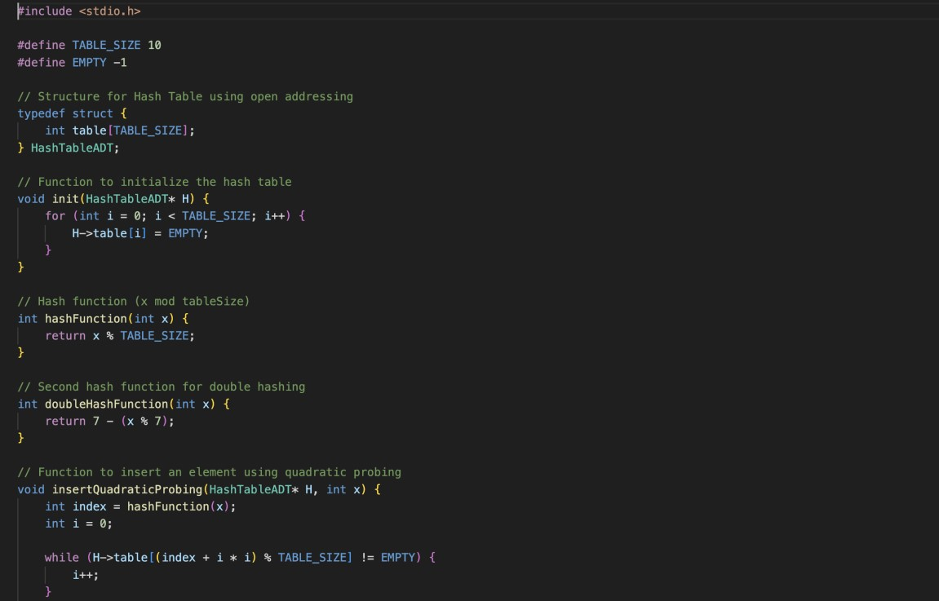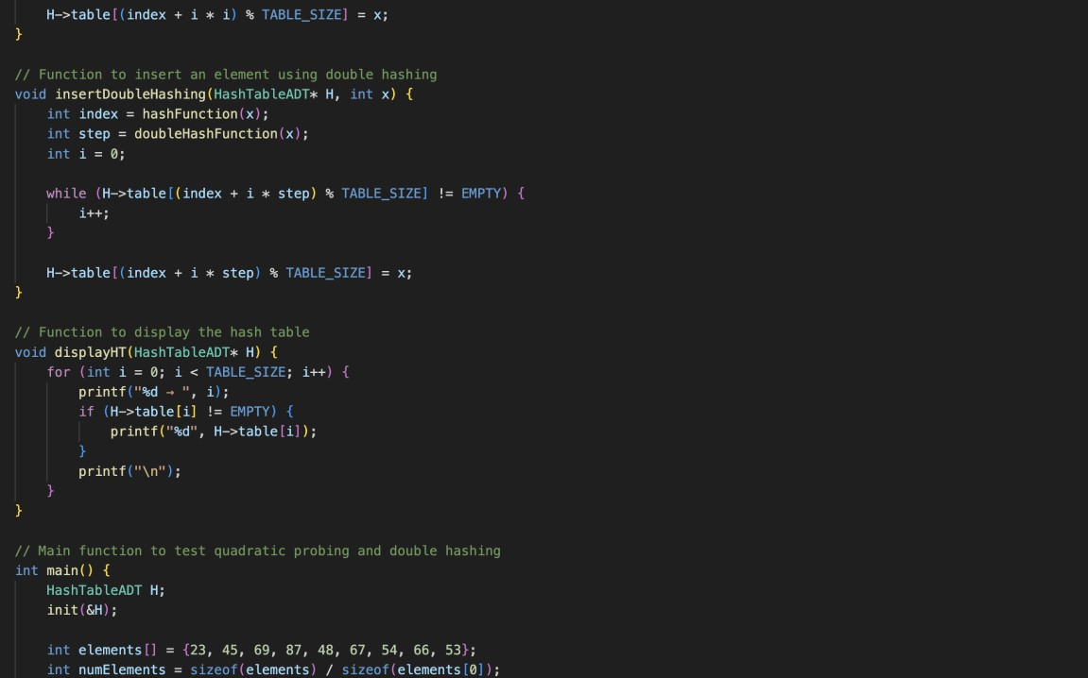

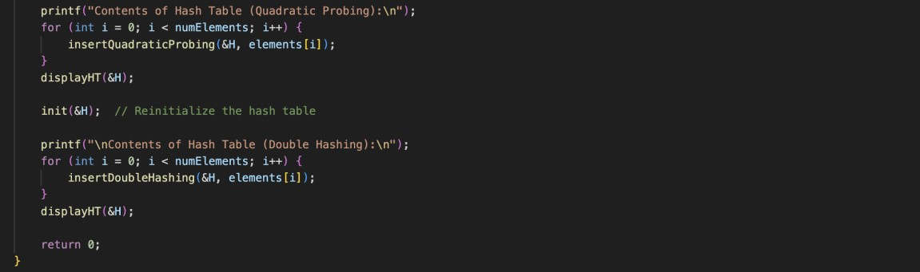

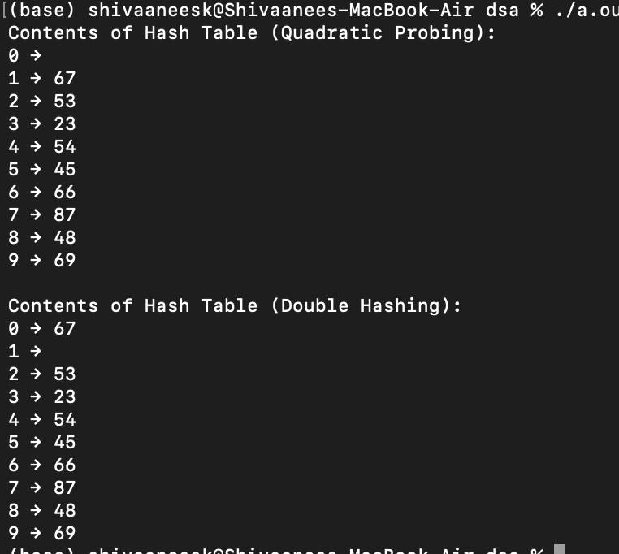

Technical Outcomes:

|  |  |  |
| --- | --- | --- |
| Design | 3 |  |
| Understanding DS | 3 |  |
| Usage of DS | 2 | Needs improvement |
| Debugging | 3 |  |

Best Practices:

|  |  |  |
| --- | --- | --- |
| Design before coding | 3 |  |
| Usage of algo | 3 |  |
| Multifile | 1 | Needs improvement |
| versioning | 3 |  |